QUESTION 1 MEDIA EVALUATION

Cinematography

The cinematography used in my Yurei film varies throughout but meets some of the conventions of cinematography in Yurei films.
Firstly, at the start of the film, we use montage of everyday life, like frying eggs and toast, putting the kettle on, stirring tea etc. This is conventional for a Yurei film because often, the movie starts with a normal, everyday life, which firstly, builds suspense and enigma to the point where the Yurei is present and an attack or a kill happens.

An example can be used from One Missed Call, where the movie opens to several shots that are shot rapidly. For me personally, this is effective, as its not only a usual, present day setting but also slowly builds up the enigma because the audience waits long till the Yurei is shown and this long build up creates that effect.

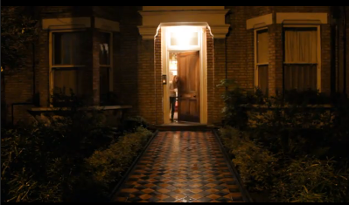
The long take of the house towards the end of the end of the film, creates the feel that someone is targeting the house and looking at it.

When Olivia runs out, in contrast to the house, she is very small, which symbolizes that maybe now after being represented as a protagonist she is the victim too.

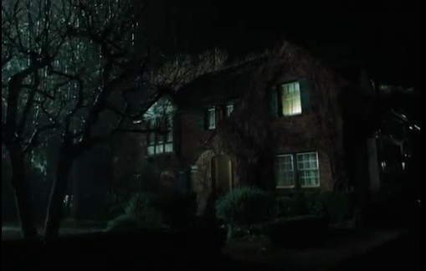

This use of cinematography is as well conventional to Yurei horror, as in the majority of films, either the opening shot is of a big house or the action or attack of the Yurei is in the house.
An example can be seen from the opening of
The Ring, when the first shot we see is of a big house. The darkness and rain is conventional to use to portray the Yurei and shows the audience that something will happen in the house.

The high angle of the camera used in the middle of the opening of our film is used to depict the victims.

The same shot is used in The Ring, when one of the girls is sitting on the floor and the camera is in a high angle. It was an efficacious shot, as the audience immediately understands who the victim is in the film and that something will happen to her.
We used a high angle shot on both of our characters, as we wanted to confuse the audience more so that at the start they think that Olivia is a protagonist, but after Leila is attacked, Olivia become the victim as well, therefore this high angle directed at both of them gives a sign that they both are targeted.

Lastly, an over the shoulder shot, when Olivia is checking her Facebook on her laptop, is used for the audience to focus on this object.

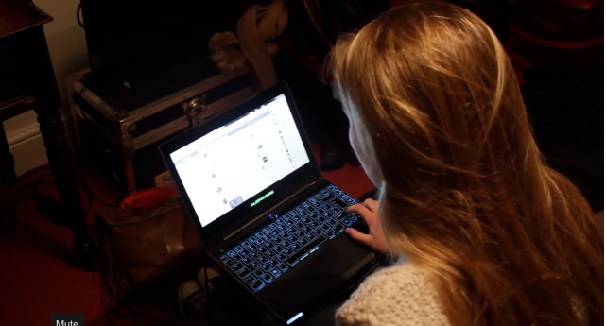

It acts as a signifier, just like in The Curse, when the man puts the files about the boy, who is then soon discovered to be the Yurei, on the table.

The audience understands that these files are an important signifying prop used and that it has the message hidden.

Lighting

The lighting used in many Yurei films challenges the forms of a horror movie, as instead of dark light, Yurei films start with natural, high key lighting and as the tension builds up to the moment when the Yurei character is introduced to the audience, the lighting gets darker. This type of lighting is conventional for a Yurei film, as this makes the film more realistic, and that is what scares the audience even more.

For our film, we decided to follow these conventions of a Yurei film because the use of lighting in this type of genre is not only crucial but also effective in order for the film to be realistic and to build the tension easier.

At the start of our 2-minute film, we used natural lighting to create a natural sense of the film. Often, Yurei films start with an everyday, normal life routine and during that day, something happens, like a Yurei attack. We therefore started the film with the use of natural lighting to follow the conventions of a Yurei film.

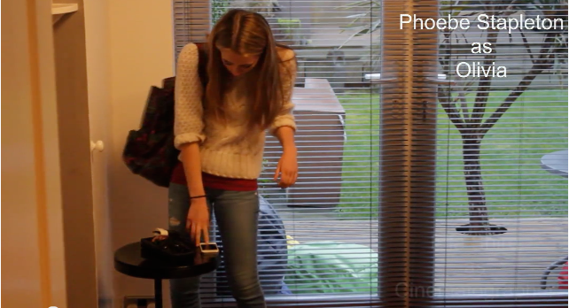

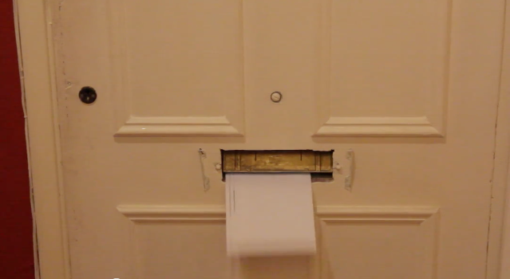

As it gets towards the end, the sudden lighting change can be noticed. It gets darker and when one of the characters goes outside, the audience sees how dark it is.
The lighting used is still natural, but when filming, we especially filmed the last part early in the morning and the opening sequence later in the day. This is because we didn’t have the budget to buy and use specific lighting props, although we had the possibility to use a reflector or any lamps.

We decided to use this kind of lighting as its once again conventional for a Yurei film and secondly, when watching One Missed Call, we thought that the lighting they used was very effective when firstly, the girl is in the restaurant, the lighting used was bright and as soon as she and her other friend went to the toilet, the lighting didn’t change to dark, but it was much dimmer.
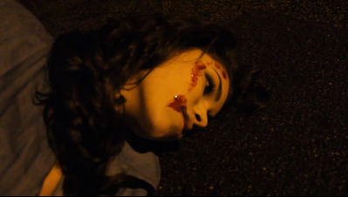
This acted as a signifier to the audience that the Yurei character is present somewhere. By using the same type of lighting in our film, we intended to signify the audience about the Yurei and that something is about to happen soon.

Sound

Yurei films generally don’t use a lot of non-diegetic music. It is often diegetic in order for the film to be more realistic and present day set so that the suspense and tension builds up much quicker and easier. Our group decided to follow the conventions of the sound use in Yurei films and used only two pieces of non-diegetic music.

The first piece of non-diegetic music acts as a sound bridge for the couple of scenes. This is a conventional and effective use of sound in Yurei films.
For example in The Curse, a specific sound is used at the start of the film and then bridges for 2-3 scenes. This creates a smooth flow of the shots and shows the realistic, normal day of the characters.

The non-diegetic sound used when the letters appear through the letterbox signifies the ‘device’ through which the Yurei character normally appears in films. The same sound of the Facebook message is heard later in our two-minute film, when Olivia receives a message from someone saying “Leila is in a coma”. This time the sound is diegetic.

An example where this conventional use of sound is used is in The Curse, when the audience hears the cry of the cat. The audience doesn’t take notice of this sound and only later on do they understand that this was a signifier that this is linked to the Yurei character, just as we chose to include the Facebook message.

Mise en scene

Overall, the mise en scene used in our film is conventional for Yurei films because it is contemporary to when the film was shot. Its modern and the setting and costumes used are present day.

There is always an important prop used during the film, and it usually the ‘device’ through which the Yurei communicates with its victims.
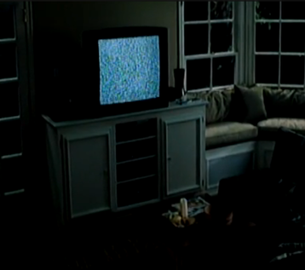

The Ring

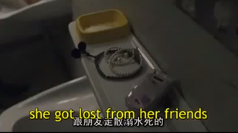

One Missed Call

Narrative

The narrative used in our film is very conventional for a Yurei film, as in most of them; the film starts with showing the ‘day’ of the character, usually the victim. This long introduction bores the audience sometimes, but usually, as seen from the market research, the majority of people find the long introduction, before the Yurei attack or death happens, very effective as it builds up the tension and creates an enigma.

Since there were a few people that said the long introduction bores them, it was hard to decide how our film is going to be. Maybe a death in the start to catch the audiences attention and then use a flashback of how it happened? But because our film had to be 2 minutes long, we decided to use the conventional narrative- Yurei introduced to the audience, meaning, that at the end of the film, there would be a death of one of the characters or a sign that the Yurei is now present.

Later on during the film, a conventional action to happen is a fake scare. Like used in The Ring, when the tension builds up for a long time and then one of the victims starts choking and falls on the laps of the other girl. Straight away the audience thinks that the Yurei communicated through some device and she is attacked by it now. But suddenly, the girl informs that she was just joking and there is big relief for the audience.

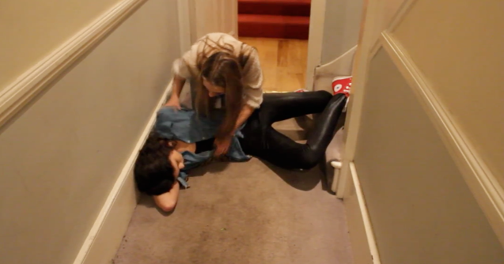
We decided to include a fake scare in our film not only because it is conventional for a Yurei film but also, because this breaks the tension and suspense for the audience and as soon as the ‘real’ Yurei attack happens, the audience will be slightly confused if its fake or not. The tension wont be that high but as soon as they understand that this death is now real, it will leave them in terror and the tension built will be much higher.

